**Using Resource file for storing messages**

As of *10/8/2015* we have added a resource file in the BSS.Web project inside folder “**App_GlobalResources**” named **“Resource.resx”**. The purpose of this file is to store all save all static messages which needs to be returned to the client code from the server application. The folder “App_GlobalResources” also have some other *sample* resource files with languages and country code in the name (Ex. *es-mx* for Spanish-Mexican), which are used for localization purposes, and we can use it in future if need be.

1. **How to add new messages to the resource file:** 
   1. Open the Resource file “Resource.resx” in visual studio.

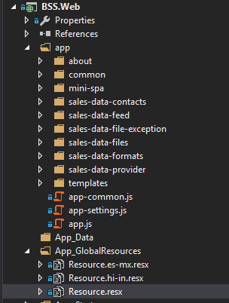

* 1. Add new line for the message

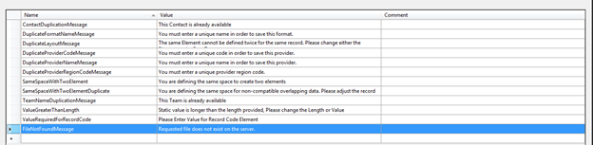

* 1. Enter the Name (which is the Key) and Value (which is the message) and save the file

1. **How to use the messages in code:** 
   1. Add the new message added as property to the IResource interface and ResourceManager class.
   2. Return the message from Resource file here
   3. *public string FileNotFoundMessage*
   4. *{*
   5. *get { return Resource.FileNotFoundMessage; }*
   6. *}*
   7. Use the message in API